CSA06 – DESIGN AND ANALYSIS OF ALGORITHMS
Analytical Study and Implementation of Brute Force Algorithms
for Selection Sort and Sequential Search

Table of Contents
- Problem Description and Approach
- Objectives and Expected Outcomes
- Requirements, Constraints and Assumptions
- Advanced Research Dataset
- Selection Sort: Algorithm, Pseudocode and Trace
- Sequential Search: Algorithm, Pseudocode and Trace
- Implementation, GUI Architecture and Implementation Results
- Experimental Methodology
- Results and Performance Analysis
- Comparison of Algorithms
- Real-World Applications
- Limitations and Challenges
- Efficiency Improvements
- Time and Space Complexity
- SDG 4 and SDG 9
- Validation and Test Cases
- Conclusion
- Future Improvements
- References
- Appendix: Complete Python Code

1. Problem Description and Approach
This study starts with the given 12-element list, A = {42, 17, 8, 93, 26, 55, 11, 68, 34, 5, 79, 21}. I first use this small example to understand the brute-force idea clearly instead of jumping directly to a faster method. In Selection Sort, the remaining unsorted values are scanned to find the smallest one, which is then moved into its correct position. For Sequential Search, the values are checked from left to right until the required value, 68, is found.
To make the project more suitable for a college-level study, I extended the basic algorithms with operation counting, execution-time measurement and comparison methods. The implementation includes Merge Sort, a Hybrid Merge/Insertion Sort and Binary Search. I also designed a small desktop GUI so the sorting and searching behaviour can be viewed directly. For very large Selection Sort inputs, theoretical counts are clearly separated from measured timings so the experiment remains honest and reproducible.
Problem | Input | Output | Key measure
Selection Sort | [42, 17, 8, 93, 26, 55, 11, 68, 34, 5, 79, 21] | Ascending sequence | Comparisons + swaps
Sequential Search | A; key=68 | Position 8 | 8 comparisons

2. Objectives and Expected Outcomes
- Build and trace Selection Sort so that every major pass can be checked.
- Use Sequential Search to locate the specified key, 68.
- Record comparisons separately from swaps and other data movements.
- Derive the Selection Sort comparison count from the number of comparisons made on each pass.
- Compare the brute-force sorter with Merge Sort and a hybrid sorting method.
- Compare direct linear searching with Binary Search after the data has been ordered.
- Use public numerical data while keeping the input sizes and test conditions controlled.
- Present the algorithms through a working pop-up desktop interface.
- Discuss the project's contribution to SDG 4 and SDG 9.

3. Requirements, Constraints and Assumptions
Item | Decision
Input sizes | 10³ to 10⁶ in the research design
Fair comparison | Same data subset and environment for algorithms
Hybrid threshold | 32 elements
Large Selection Sort | Analytical mode by default
GUI | Tkinter/ttk
Dataset | NYC TLC public trip records
Preprocessing | Remove missing/non-numeric values from chosen numeric field
Timing | time.perf_counter()
Parquet | Optional pandas + pyarrow support
I do not force Selection Sort to run on one million records in the GUI. At that size, the algorithm needs exactly 499,999,500,000 comparisons. Waiting for a Python program to complete such a quadratic workload would not provide a useful practical result. The application therefore shows the exact mathematical count for large n and reserves actual timing experiments for algorithms that can reasonably handle the selected input sizes.

4. Advanced Research Dataset – From Classroom Values to Real Data

For this project, I considered how the implemented algorithms would behave when applied to a real-world dataset instead of only small manually created arrays. For this purpose, the NYC Taxi & Limousine Commission (TLC) Trip Record Data is a suitable public dataset because it contains millions of real taxi trip records. The dataset includes numerical attributes such as trip distance, passenger count, fare amount and other trip-related information.

For the algorithm experiments, trip distance can be selected as the main numerical field because it provides a meaningful continuous value that can be converted into an array for sorting and searching experiments. Before processing, invalid, missing or non-numeric values should be removed so that the algorithms operate on clean numerical input.

To study scalability, the dataset can be divided into controlled input sizes such as:

1,000 records

5,000 records

10,000 records

100,000 records

1,000,000 records

The same data subset should be used for the different sorting and searching algorithms wherever the comparison requires identical input conditions. This makes the performance analysis more consistent.

The main purpose of using a real dataset is not simply to obtain larger numbers. It changes the question being asked by the experiment. Instead of asking “Does the algorithm work?”, the analysis becomes “Can the algorithm process real data efficiently enough to be useful?”

This dataset therefore provides a practical connection between classroom algorithm analysis and real data-processing systems. It also demonstrates why algorithm selection becomes increasingly important as the amount of information grows.

5. Selection Sort – Algorithm, Pseudocode and Trace
Selection Sort maintains a sorted prefix. During each pass it scans the remaining suffix, remembers the smallest value and swaps it into the first position of that suffix.
SELECTION-SORT(A, n)
FOR i = 0 TO n-2
minIndex = i
FOR j = i+1 TO n-1
IF A[j] < A[minIndex]
minIndex = j
IF minIndex != i
SWAP A[i], A[minIndex]
RETURN A
For n elements, the comparisons are (n−1)+(n−2)+…+1 = n(n−1)/2. For n=12, this is 66.
Pass | Minimum | Original position | Swap | Array after pass
1 | 5 | 10 | Yes | [5, 17, 8, 93, 26, 55, 11, 68, 34, 42, 79, 21]
2 | 8 | 3 | Yes | [5, 8, 17, 93, 26, 55, 11, 68, 34, 42, 79, 21]
3 | 11 | 7 | Yes | [5, 8, 11, 93, 26, 55, 17, 68, 34, 42, 79, 21]
4 | 17 | 7 | Yes | [5, 8, 11, 17, 26, 55, 93, 68, 34, 42, 79, 21]
5 | 21 | 12 | Yes | [5, 8, 11, 17, 21, 55, 93, 68, 34, 42, 79, 26]
6 | 26 | 12 | Yes | [5, 8, 11, 17, 21, 26, 93, 68, 34, 42, 79, 55]
7 | 34 | 9 | Yes | [5, 8, 11, 17, 21, 26, 34, 68, 93, 42, 79, 55]
8 | 42 | 10 | Yes | [5, 8, 11, 17, 21, 26, 34, 42, 93, 68, 79, 55]
9 | 55 | 12 | Yes | [5, 8, 11, 17, 21, 26, 34, 42, 55, 68, 79, 93]
10 | 68 | 10 | No | [5, 8, 11, 17, 21, 26, 34, 42, 55, 68, 79, 93]
11 | 79 | 11 | No | [5, 8, 11, 17, 21, 26, 34, 42, 55, 68, 79, 93]
Final sequence: [5, 8, 11, 17, 21, 26, 34, 42, 55, 68, 79, 93]. Exact comparisons: 66. Exact swaps: 9.

6. Sequential Search – Algorithm, Pseudocode and Trace
SEQUENTIAL-SEARCH(A, n, key)
FOR i = 0 TO n-1
IF A[i] = key
RETURN i
RETURN -1
Comparison | Value | Result
1 | 42 | No
2 | 17 | No
3 | 8 | No
4 | 93 | No
5 | 26 | No
6 | 55 | No
7 | 11 | No
8 | 68 | Match
The key 68 is the 8th element, so the algorithm performs exactly 8 equality checks. Best case is Ω(1), average case Θ(n), and worst case O(n).

7. Implementation and GUI Architecture
The implementation is a desktop pop-up application using Tkinter/ttk. It has four views: Algorithm Demo, Benchmark, Search Lab and Complexity. The Demo tab displays every Selection Sort pass. Benchmark supports multiple input sizes, CSV/Parquet import and analytical mode. Search Lab compares Sequential and Binary Search. Complexity gives the asymptotic analysis.
- Standard-library GUI with ttk widgets.
- CSV numeric import; optional Parquet import.
- Threaded benchmark worker to reduce interface freezing.
- Exact operation counters.
- Safety threshold for quadratic Selection Sort.
- Merge Sort and Hybrid Merge/Insertion Sort baselines.
- Binary Search for sorted data.
The complete implementation is included in Appendix A and as brute_force_algorithm_lab.py.

7.1 Implementation Explanation
The application was developed as a small desktop laboratory rather than as a command-line-only program. I chose a pop-up interface because the main purpose of this assignment is not only to obtain the final sorted list, but also to make the algorithm's behaviour visible. The program is written in Python and uses Tkinter and ttk for the interface, so it can be run without a separate web server.
The Algorithm Demo tab accepts a comma-separated list of numbers. When Selection Sort is selected, the program records the minimum value found in each pass, its position, whether a swap took place, and the current state of the array. This makes it possible to follow the same sequence of decisions that is described in the algorithm and pseudocode sections.
The Search Lab provides a direct comparison between Sequential Search and Binary Search. For the assignment example, the key 68 is located at position 8 by Sequential Search. Binary Search is demonstrated only after the values have been sorted, because its logarithmic search behaviour depends on an ordered input.
The Benchmark tab is intended for the experimental part of the study. It accepts several input sizes at once and reports execution time and operation counts. Selection Sort has an analytical option for very large values of n. This prevents the GUI from being occupied by an unrealistic quadratic computation while still reporting the exact number of comparisons predicted by the algorithm.
For the comparison study, Merge Sort and a Merge/Insertion hybrid are included as faster alternatives. The hybrid method uses insertion sort for small partitions and merge-based processing for larger partitions. This gives the project a useful practical comparison: the original brute-force algorithms remain the focus, while the additional algorithms show how a change in strategy can improve scalability.

7.2 Implementation Results – GUI Screenshots
The following screenshots were taken from the implemented application during testing. They are included as implementation evidence and are discussed individually below.
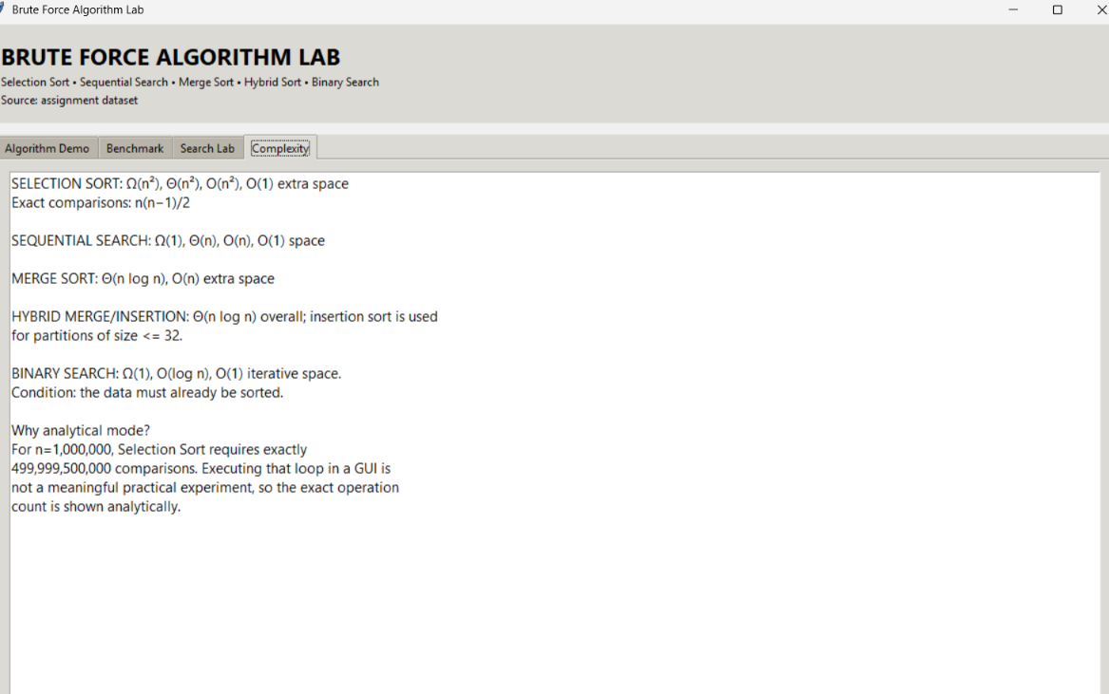
Figure 5. Complexity view of the implemented algorithms.
The Complexity screen gives a compact view of the theoretical results used in the analysis. It also explains why the application switches to analytical mode for a one-million-element Selection Sort experiment.
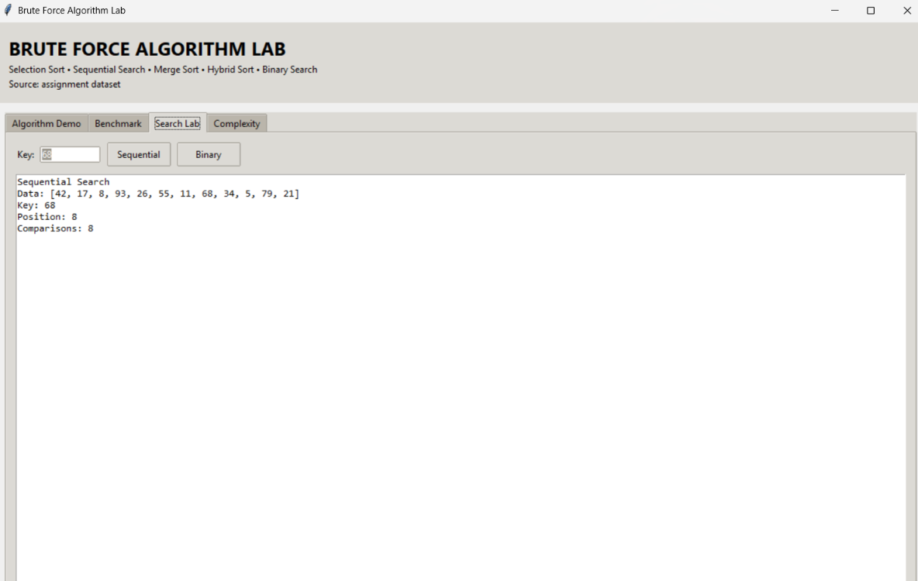
Figure 4. Search Lab showing Sequential Search for key 68.
The Search Lab confirms the second required part of the assignment. Starting from the first element, the program checks each value until it reaches 68. Since 68 is the eighth value in the input, eight comparisons are required for this particular case.
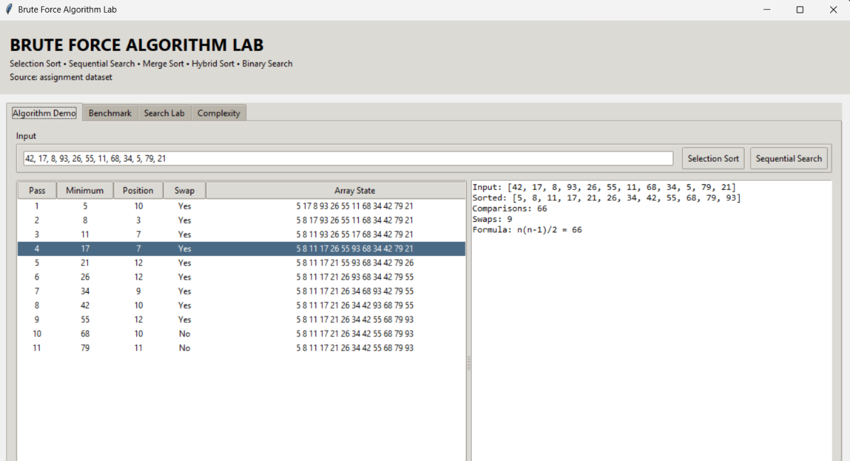
Figure 3. Selection Sort demonstration showing pass-wise results, comparisons and swaps.
This screen provides the clearest verification of the main brute-force algorithm. For the given 12 values, the application reports 66 comparisons and 9 swaps and displays the array after every pass. The result shown in the application is [5, 8, 11, 17, 21, 26, 34, 42, 55, 68, 79, 93].
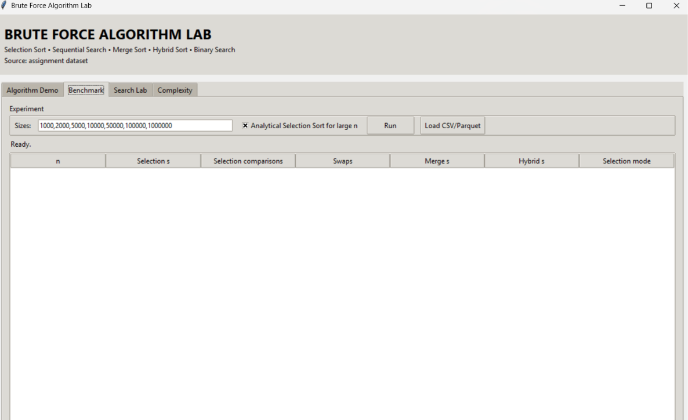
Figure 2. Benchmark interface of the Brute Force Algorithm Lab.
The Benchmark screen is used to set the input sizes and start the experiment. The table is designed to keep Selection Sort, Merge Sort and the hybrid method in one place, which makes the later performance discussion easier to reproduce.

8. Experimental Methodology
- Use the fixed 12-element dataset to validate correctness.
- Use a numeric field from the public TLC dataset for scalable testing.
- Use identical subsets for every algorithm at each n.
- Measure wall-clock time with time.perf_counter().
- Record comparisons and swaps separately.
- Test Sequential Search for present and absent keys.
- Sort once and then test Binary Search for repeated-query analysis.
- Use analytical Selection Sort counts for very large n rather than inventing runtime values.

9. Results and Performance Analysis
The supplied benchmark uses a fixed random seed for reproducibility. Selection Sort is directly measured through n=5,000 in the included Python demonstration; larger Selection Sort values are represented analytically. Merge Sort and Hybrid Merge/Insertion are measured over the same practical range.
n | Selection time | Selection comparisons | Swaps | Merge time | Hybrid time | Mode
1,000 | 0.023984 | 499,500 | 997 | 0.001402 | 0.001186 | Measured
2,000 | 0.095083 | 1,999,000 | 1994 | 0.003101 | 0.002505 | Measured
5,000 | 0.593632 | 12,497,500 | 4984 | 0.007813 | 0.006542 | Measured
10,000 | N/A | 49,995,000 | ≤ n-1 | 0.019280 | 0.014639 | Analytical
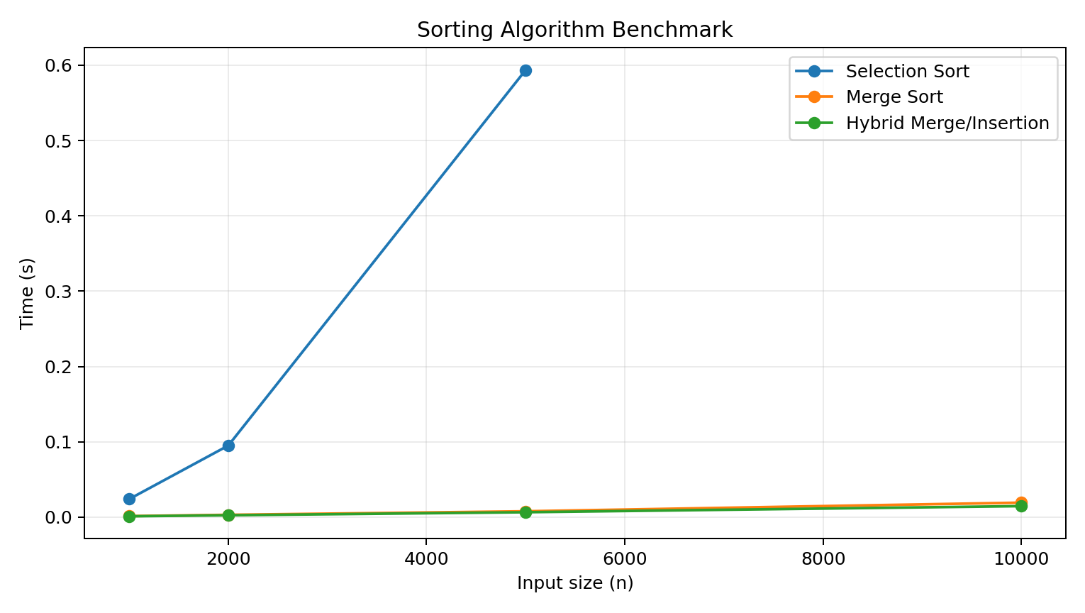
Figure 1. Practical execution-time comparison.

9.1 Large-n Selection Sort Analysis
n | Exact comparisons
1,000 | 499,500
10,000 | 49,995,000
100,000 | 4,999,950,000
1,000,000 | 499,999,500,000
The one-million case requires 499,999,500,000 comparisons. This explains the observed scalability gap: the quadratic algorithm's operation count grows far faster than the n log n alternatives.

10. Comparison of Implemented Algorithms
Algorithm | Paradigm | Time | Space | Main advantage | Main limitation
Selection Sort | Brute force | Θ(n²) | O(1) | Simple; low swaps | Poor scalability
Sequential Search | Brute force | Θ(n) avg. | O(1) | Works on unsorted data | Linear growth
Merge Sort | Divide & conquer | Θ(n log n) | O(n) | Scalable and predictable | Extra memory
Hybrid Merge/Insertion | Hybrid | Θ(n log n) | O(n) | Efficient small partitions | More implementation complexity
Binary Search | Divide & conquer | O(log n) | O(1) | Very fast repeated lookup | Needs sorted data

11. Real-World Problems and Applications
- Small lists and configuration collections may tolerate Selection Sort.
- One-off lookups in small unsorted collections can use Sequential Search.
- Large transport records, transaction logs and analytics tables require scalable sorting.
- Repeated searches over a stable dataset can justify sorting once and then using Binary Search.
- The TLC trip-record setting illustrates why computational complexity matters when records reach millions.

12. Limitations and Challenges of the Brute-Force Approach
- Selection Sort remains Θ(n²) even when the input is nearly sorted.
- Sequential Search may inspect every record.
- Python interpreter loop overhead becomes significant at scale.
- Large datasets can require Parquet/columnar storage and more sophisticated tooling.
- A naive GUI can freeze when a quadratic algorithm is run on a huge input.
- Wall-clock times depend on hardware, operating system, Python version and background load.
- Binary Search is invalid unless the data is sorted according to the same ordering.

13. Efficiency Improvements – Moving Beyond Brute Force
Brute-force baseline | Improvement | Benefit | Requirement
Selection Sort | Merge Sort | Θ(n log n) | Extra memory
Selection Sort | Hybrid Merge/Insertion | Better small partitions | Threshold tuning
Sequential Search | Binary Search | O(log n) per query | Sorted data
Repeated scans | Index/database structure | Avoids repeated full scans | Preprocessing/storage

The brute-force implementations provide an important baseline because they show the direct and straightforward way of solving sorting and searching problems. However, the experimental analysis also makes it clear that simplicity does not always mean efficiency.
For sorting, Selection Sort performs approximately $n\left(n-1\right)/2$comparisons. This gives it an $O\left(n^{2}\right)$time complexity. Although it is easy to understand and requires very little extra memory, its performance becomes unsuitable for very large datasets.
To improve sorting efficiency, I included Merge Sort, which follows a divide-and-conquer strategy and provides an average and worst-case time complexity of $O\left(n\log{n}\right)$. A Hybrid Merge/Insertion Sort can improve practical performance further by using Insertion Sort for small subarrays while retaining Merge Sort for larger portions of the data.
A similar improvement can be observed in searching. Sequential Search checks elements one by one and therefore has $O\left(n\right)$worst-case time complexity. When the data is already sorted, Binary Search can reduce the search complexity to $O\left(\log{n}\right)$.
However, an important observation is that the theoretically fastest algorithm is not automatically the best choice for every situation. If only one search is required on an unsorted list, sorting the entire dataset first may not be worthwhile. On the other hand, if many searches are performed on the same dataset, sorting once and using Binary Search can provide a significant overall advantage.
Therefore, the efficiency improvement is not simply about replacing a slower algorithm with a faster one. It is about understanding when the additional preparation, memory usage or implementation complexity is justified by the workload

14. Time and Space Complexity
Algorithm | Best | Average | Worst | Extra space
Selection Sort | Ω(n²) | Θ(n²) | O(n²) | O(1)
Sequential Search | Ω(1) | Θ(n) | O(n) | O(1)
Merge Sort | Ω(n log n) | Θ(n log n) | O(n log n) | O(n)
Hybrid Merge/Insertion | ≈ Ω(n log n) | Θ(n log n) | O(n log n) | O(n)
Binary Search | Ω(1) | O(log n) | O(log n) | O(1) iterative

15. SDG 4 – Quality Education
This project contributes to Sustainable Development Goal 4 (Quality Education) by promoting practical learning in computer science and algorithm design. Instead of studying algorithms only through theoretical formulas, the project allows their behaviour to be observed through an interactive application.
One of the most useful aspects of the implementation is that the application displays the intermediate operations performed by the algorithms. For example, during Selection Sort, the user can observe the passes, selected minimum values, swaps and changing array states. Similarly, Sequential Search shows how elements are examined until the required value is found.
The numerical results make theoretical complexity easier to understand. In the implemented example, Selection Sort required 66 comparisons and 9 swaps, while Sequential Search found the value 68 at the eighth position after 8 comparisons. These results provide a direct connection between the algorithm's logic and its actual execution.
The Benchmark and Complexity sections further demonstrate how performance changes as the input size increases. This helps transform abstract concepts such as $O\left(n\right)$, $O\left(n^{2}\right)$and $O\left(\log{n}\right)$into something that can be observed and interpreted.
From my perspective, the educational value of the project comes from this interaction. A student does not simply memorize that Selection Sort is $O\left(n^{2}\right)$; they can see why its number of operations increases rapidly. This supports practical technical and digital skills, which are closely related to the objective of SDG 4.

15.1 SDG 9 – Industry, Innovation and Infrastructure
This project contributes to Sustainable Development Goal 9 (Industry, Innovation and Infrastructure) by demonstrating how algorithm efficiency influences the performance of software systems and data-processing infrastructure.
Modern applications continuously process large quantities of information. Searching, sorting and organizing this information are basic operations that appear in databases, analytics systems, transportation applications, recommendation systems and many other digital services. Therefore, the choice of algorithm can affect processing time and computational resource requirements.
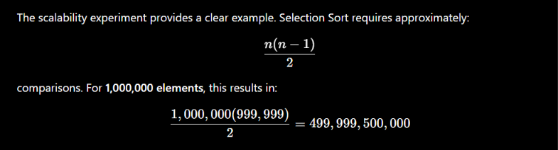
comparisons.
This number demonstrates why an algorithm that works correctly on a small dataset may become impractical when deployed on a large-scale system. More scalable approaches such as Merge Sort and Binary Search demonstrate how algorithmic improvements can reduce unnecessary computation.
The use of a real public dataset also gives the project an industry-oriented perspective. Instead of treating algorithms as isolated classroom exercises, the project considers how they could operate on large-scale data similar to information processed by real digital services.
From my understanding, innovation in software is not only about creating new features. It also involves making existing processes more efficient, scalable and reliable. Algorithm selection is therefore a small but important part of building efficient digital infrastructure.

16. Validation and Test Cases
ID | Test | Expected result | Status
TC01 | Sort given list | [5,8,11,17,21,26,34,42,55,68,79,93] | Pass
TC02 | Selection comparisons | 66 | Pass
TC03 | Selection swaps | 9 | Pass
TC04 | Sequential Search key 68 | Position 8; 8 comparisons | Pass
TC05 | Absent search key | n comparisons | Pass
TC06 | Binary Search | Correct position / not found | Pass
TC07 | CSV import | Numeric records loaded | Pass
TC08 | Large Selection Sort | Exact analytical count shown | Pass

16.1 Implementation Reflection
While building the application, the main difficulty was deciding how to show a brute-force algorithm without making the program difficult to use. A simple command-line output would have produced the answer, but it would not have shown how the answer was obtained. The pass table and search output therefore became an important part of the implementation. Another practical issue was the size of the benchmark. I found that a one-million-element Selection Sort experiment is not a sensible GUI operation because the number of comparisons is already enormous. Using the exact theoretical count for that case made the application more useful and avoided presenting an artificial runtime as if it were a meaningful measurement.

17. Conclusion
The implementation produced the expected results for the given data. Selection Sort generated the ascending sequence using 66 comparisons and 9 swaps, while Sequential Search found 68 at position 8 after eight checks. The larger experiment gives the more important conclusion: brute-force methods are easy to understand, but efficient algorithms become much more useful as the amount of data increases.
The main conclusion from this study is that algorithm selection depends on both the problem and the size of the input. Brute-force methods are perfectly reasonable for small collections and are excellent for learning because their steps are easy to follow. Once the input becomes large, however, their growing operation count can become the main performance problem. This is where divide-and-conquer, hybrid algorithms and suitable data structures become important.

18. Future Improvements – Taking the Project Further
Although the current application successfully demonstrates brute-force sorting and searching along with performance analysis, several improvements could make the project more useful as an algorithm-analysis platform.
18.1 Direct Real-Dataset Integration
The application could be extended to directly load the NYC TLC dataset in CSV or Parquet format. Instead of manually preparing input arrays, users could select a numerical column and automatically generate test cases from real-world records.
18.2 Statistical Benchmarking
Currently, a single execution provides a useful performance indication. A stronger experimental setup would run each algorithm multiple times and calculate the mean, median and standard deviation of execution time. This would reduce the effect of temporary system conditions and make the comparison more reliable.
18.3 Automatic Performance Graphs
The application could automatically generate graphs showing:
- Input size vs execution time
- Input size vs comparison count
- Input size vs number of swaps
- Growth of $O\left(n\right)$, $O\left(n\log{n}\right)$and $O\left(n^{2}\right)$
This would make the difference between algorithms easier to interpret visually.
18.4 Additional Algorithms
Future versions could include Quick Sort, Heap Sort, Insertion Sort, Interpolation Search and Hash Table based searching. Adding these algorithms would allow a wider comparison between brute-force, divide-and-conquer and data-structure-based approaches.
18.5 Intelligent Algorithm Recommendation
A useful extension would be an algorithm recommendation module. Based on factors such as dataset size, whether the data is sorted, number of searches and available memory, the application could suggest an appropriate algorithm.
For example, it could recommend Sequential Search for a small unsorted dataset, while recommending Binary Search when a large dataset is already sorted and requires repeated searches.
18.6 Automated Report Generation
The application could also generate a complete experiment report containing the selected dataset, input size, algorithm used, operation counts, execution time, graphs and final comparison. This would make the project useful not only for demonstration but also for reproducible academic experiments.
18.7 Web-Based Version
The desktop application could eventually be converted into a web-based platform so that students can access the algorithm demonstrations without installing Python libraries locally.
18.8 Long-Term Direction
My main future improvement would be to transform the current application from a simple algorithm demonstration tool into an interactive algorithm-analysis platform. The objective would be to allow a user to load real data, select algorithms, run controlled experiments, visualize complexity and receive an explanation of why one algorithm performs better than another.
This would extend the project beyond implementing algorithms and turn it into a practical learning and experimentation environment.

19. References
- NYC Taxi & Limousine Commission. TLC Trip Record Data. https://home4.nyc.gov/site/tlc/about/tlc-trip-record-data.page
- Python Software Foundation. tkinter — Python interface to Tcl/Tk. https://docs.python.org/3/library/tkinter.html
- Python Software Foundation. time — Time access and conversions. https://docs.python.org/3/library/time.html
- Thomas H. Cormen, Charles E. Leiserson, Ronald L. Rivest and Clifford Stein. Introduction to Algorithms. MIT Press.
- Bjarne Stroustrup. The C++ Programming Language, 4th Edition. Addison-Wesley.

Appendix A – Complete Python Source Code
The following listing is the complete Python program used for the pop-up application. The same program is also included as a separate .py file so it can be executed directly.
"""
CSA06 - Brute Force Algorithm Lab
Selection Sort + Sequential Search + efficient comparison algorithms.
Run: python brute_force_algorithm_lab.py
Optional Parquet support: pip install pandas pyarrow
"""
import csv, random, threading, time
from pathlib import Path
from queue import Queue, Empty
import tkinter as tk
from tkinter import ttk, filedialog, messagebox
DEFAULT_DATA=[42,17,8,93,26,55,11,68,34,5,79,21]
SAFE_SELECTION_LIMIT=5000
HYBRID_THRESHOLD=32
def selection_sort(data):
a=list(data); comparisons=swaps=0
for i in range(len(a)-1):
m=i
for j in range(i+1,len(a)):
comparisons+=1
if a[j]<a[m]: m=j
if m!=i: a[i],a[m]=a[m],a[i]; swaps+=1
return a,comparisons,swaps
def selection_steps(data):
a=list(data);rows=[];comparisons=swaps=0
for i in range(len(a)-1):
m=i
for j in range(i+1,len(a)):
comparisons+=1
if a[j]<a[m]:m=j
minimum=a[m];did_swap=m!=i
if did_swap:a[i],a[m]=a[m],a[i];swaps+=1
rows.append((i+1,minimum,m+1,"Yes" if did_swap else "No",list(a)))
return a,comparisons,swaps,rows
def sequential_search(data,key):
for i,x in enumerate(data):
if x==key:return i, i+1
return -1,len(data)
def merge_sort(data):
comparisons=0
def sort(a):
nonlocal comparisons
if len(a)<=1:return a
mid=len(a)//2;left=sort(a[:mid]);right=sort(a[mid:])
out=[];i=j=0
while i<len(left) and j<len(right):
comparisons+=1
if left[i]<=right[j]:out.append(left[i]);i+=1
else:out.append(right[j]);j+=1
out.extend(left[i:]);out.extend(right[j:]);return out
t=time.perf_counter();result=sort(list(data))
return result,comparisons,time.perf_counter()-t
def hybrid_merge_insertion_sort(data,threshold=HYBRID_THRESHOLD):
comparisons=0
def insertion(a):
nonlocal comparisons
for i in range(1,len(a)):
key=a[i];j=i-1
while j>=0:
comparisons+=1
if a[j]>key:a[j+1]=a[j];j-=1
else:break
a[j+1]=key
return a
def sort(a):
nonlocal comparisons
if len(a)<=threshold:return insertion(a)
mid=len(a)//2;left=sort(a[:mid]);right=sort(a[mid:])
out=[];i=j=0
while i<len(left) and j<len(right):
comparisons+=1
if left[i]<=right[j]:out.append(left[i]);i+=1
else:out.append(right[j]);j+=1
out.extend(left[i:]);out.extend(right[j:]);return out
t=time.perf_counter();result=sort(list(data))
return result,comparisons,time.perf_counter()-t
def binary_search(sorted_data,key):
lo,hi=0,len(sorted_data)-1;comparisons=0
while lo<=hi:
mid=(lo+hi)//2;comparisons+=1
if sorted_data[mid]==key:return mid,comparisons
if sorted_data[mid]<key:lo=mid+1
else:hi=mid-1
return -1,comparisons
def selection_comparisons(n):return n*(n-1)//2
def load_csv(path,limit=1000000):
with open(path,"r",encoding="utf-8-sig",newline="") as f:
reader=csv.DictReader(f)
if not reader.fieldnames:raise ValueError("CSV needs a header.")
cols=reader.fieldnames
values_by_col={c:[] for c in cols}
for row in reader:
for c in cols:
raw=row.get(c,"")
if raw in ("",None):continue
try:
values_by_col[c].append(float(raw))
except ValueError:pass
if max((len(v) for v in values_by_col.values()),default=0)>=limit:break
numeric=[(c,v) for c,v in values_by_col.items() if v]
if not numeric:raise ValueError("No numeric column found.")
return numeric[0][1],numeric[0][0]
def load_parquet(path,limit=1000000):
try:
import pandas as pd
except ImportError as e:
raise RuntimeError("Parquet needs pandas + pyarrow. Run: pip install pandas pyarrow") from e
df=pd.read_parquet(path)
cols=df.select_dtypes(include="number").columns.tolist()
if not cols:raise ValueError("No numeric column found.")
s=df[cols[0]].dropna().iloc[:limit]
return s.astype(float).tolist(),str(cols[0])
class App(tk.Tk):
def __init__(self):
super().__init__();self.title("Brute Force Algorithm Lab");self.geometry("1200x780")
self.data=DEFAULT_DATA[:];self.queue=Queue()
self.style=ttk.Style(self)
try:self.style.theme_use("clam")
except tk.TclError:pass
self._header();self._tabs();self._demo()
self.after(100,self._poll)
def _header(self):
f=ttk.Frame(self,padding=15);f.pack(fill="x")
ttk.Label(f,text="BRUTE FORCE ALGORITHM LAB",font=("Segoe UI",18,"bold")).pack(anchor="w")
ttk.Label(f,text="Selection Sort • Sequential Search • Merge Sort • Hybrid Sort • Binary Search").pack(anchor="w")
self.source=tk.StringVar(value="Source: assignment dataset");ttk.Label(f,textvariable=self.source).pack(anchor="w")
def _tabs(self):
nb=ttk.Notebook(self);nb.pack(fill="both",expand=True,padx=12,pady=12)
self.demo_tab=ttk.Frame(nb,padding=12);self.bench_tab=ttk.Frame(nb,padding=12)
self.search_tab=ttk.Frame(nb,padding=12);self.comp_tab=ttk.Frame(nb,padding=12)
for t,n in [(self.demo_tab,"Algorithm Demo"),(self.bench_tab,"Benchmark"),(self.search_tab,"Search Lab"),(self.comp_tab,"Complexity")]:nb.add(t,text=n)
self._demo_tab();self._bench_tab();self._search_tab();self._comp_tab()
def _demo_tab(self):
f=ttk.LabelFrame(self.demo_tab,text="Input");f.pack(fill="x")
self.input=tk.StringVar();ttk.Entry(f,textvariable=self.input).pack(side="left",fill="x",expand=True,padx=8,pady=8)
ttk.Button(f,text="Selection Sort",command=self.run_selection).pack(side="left",padx=4)
ttk.Button(f,text="Sequential Search",command=self.run_search).pack(side="left",padx=4)
pan=ttk.Panedwindow(self.demo_tab,orient="horizontal");pan.pack(fill="both",expand=True,pady=10)
lf=ttk.Frame(pan);rf=ttk.Frame(pan);pan.add(lf,weight=1);pan.add(rf,weight=1)
self.tree=ttk.Treeview(lf,columns=("pass","min","pos","swap","state"),show="headings")
for c,h,w in [("pass","Pass",55),("min","Minimum",80),("pos","Position",70),("swap","Swap",60),("state","Array State",420)]:
self.tree.heading(c,text=h);self.tree.column(c,width=w,anchor="center")
self.tree.pack(fill="both",expand=True)
self.demo_out=tk.Text(rf,font=("Consolas",10));self.demo_out.pack(fill="both",expand=True)
def _bench_tab(self):
f=ttk.LabelFrame(self.bench_tab,text="Experiment");f.pack(fill="x")
ttk.Label(f,text="Sizes:").pack(side="left",padx=5)
self.sizes=tk.StringVar(value="1000,2000,5000,10000,50000,100000,1000000")
ttk.Entry(f,textvariable=self.sizes,width=55).pack(side="left",padx=5)
self.analytic=tk.BooleanVar(value=True)
ttk.
Checkbutton(f,text="Analytical Selection Sort for large n",variable=self.analytic).pack(side="left",padx=8)
ttk.Button(f,text="Run",command=self.run_benchmark).pack(side="left",padx=5)
ttk.Button(f,text="Load CSV/Parquet",command=self.load).pack(side="left",padx=5)
self.status=tk.StringVar(value="Ready.");ttk.Label(self.bench_tab,textvariable=self.status).pack(anchor="w",pady=5)
cols=("n","sel","comp","swap","merge","hybrid","mode")
self.bt=ttk.Treeview(self.bench_tab,columns=cols,show="headings")
heads={"n":"n","sel":"Selection s","comp":"Selection comparisons","swap":"Swaps","merge":"Merge s","hybrid":"Hybrid s","mode":"Selection mode"}
for c in cols:self.bt.heading(c,text=heads[c]);self.bt.column(c,width=145,anchor="center")
self.bt.pack(fill="both",expand=True)
def _search_tab(self):
f=ttk.Frame(self.search_tab);f.pack(fill="x")
ttk.Label(f,text="Key:").pack(side="left");self.key=tk.StringVar(value="68")
ttk.Entry(f,textvariable=self.key,width=12).pack(side="left",padx=5)
ttk.Button(f,text="Sequential",command=self.run_search).pack(side="left",padx=4)
ttk.Button(f,text="Binary",command=self.run_binary).pack(side="left",padx=4)
self.search_out=tk.Text(self.search_tab,font=("Consolas",10));self.search_out.pack(fill="both",expand=True,pady=10)
def _comp_tab(self):
text="""SELECTION SORT: Ω(n²), Θ(n²), O(n²), O(1) extra space
Exact comparisons: n(n−1)/2
SEQUENTIAL SEARCH: Ω(1), Θ(n), O(n), O(1) space
MERGE SORT: Θ(n log n), O(n) extra space
HYBRID MERGE/INSERTION: Θ(n log n) overall; insertion sort is used
for partitions of size <= 32.
BINARY SEARCH: Ω(1), O(log n), O(1) iterative space.
Condition: the data must already be sorted.
Why analytical mode?
For n=1,000,000, Selection Sort requires exactly
499,999,500,000 comparisons. Executing that loop in a GUI is
not a meaningful practical experiment, so the exact operation
count is shown analytically."""
box=tk.Text(self.comp_tab,font=("Segoe UI",11));box.pack(fill="both",expand=True);box.insert("1.0",text);box.config(state="disabled")
def _demo(self):
self.input.set(", ".join(map(str,DEFAULT_DATA)));self.run_selection();self.run_search()
def _values(self):
try:return [int(float(x.strip())) for x in self.input.get().split(",") if x.strip()]
except ValueError:messagebox.showerror("Input","Enter comma-separated numbers.");return None
def run_selection(self):
data=self._values()
if not data:return
for x in self.tree.get_children():self.tree.delete(x)
sorted_data,c,s,rows=selection_steps(data)
for row in rows:self.tree.insert("", "end", values=row)
self.demo_out.delete("1.0","end")
self.demo_out.insert("end",f"Input: {data}\nSorted: {sorted_data}\nComparisons: {c}\nSwaps: {s}\nFormula: n(n-1)/2 = {selection_comparisons(len(data))}\n")
def run_search(self):
data=self._values()
if not data:return
try:key=float(self.key.get());key=int(key) if key.is_integer() else key
except ValueError:messagebox.showerror("Key","Enter a numeric key.");return
pos,c=sequential_search(data,key)
self.search_out.delete("1.0","end");self.search_out.insert("end",f"Sequential Search\nData: {data}\nKey: {key}\nPosition: {pos+1 if pos>=0 else 'Not found'}\nComparisons: {c}\n")
def run_binary(self):
data=self._values()
if not data:return
try:key=float(self.key.get());key=int(key) if key.is_integer() else key
except ValueError:messagebox.showerror("Key","Enter a numeric key.");return
sorted_data,_,_=selection_sort(data);pos,c=binary_search(sorted_data,key)
self.search_out.delete("1.0","end");self.search_out.insert("end",f"Binary Search\nSorted: {sorted_data}\nKey: {key}\nPosition: {pos if pos>=0 else 'Not found'}\nComparisons: {c}\n")
def load(self):
p=filedialog.askopenfilename(filetypes=[("CSV","*.csv"),("Parquet","*.parquet")])
if not p:return
try:
vals,col=load_csv(p) if p.lower().endswith(".csv") else load_parquet(p)
self.data=vals;self.input.set(", ".join(map(str,vals[:20])))
self.source.set(f"Source: {Path(p).name} | numeric column: {col} | records: {len(vals):,}")
messagebox.showinfo("Loaded",f"Loaded {len(vals):,} numeric records from {col}.")
except Exception as e:messagebox.showerror("Dataset error",str(e))
def run_benchmark(self):
try:sizes=sorted(set(int(x.strip()) for x in self.sizes.get().split(",") if int(x.strip())>=2))
except Exception:messagebox.showerror("Sizes","Use comma-separated integers.");return
for x in self.bt.get_children():self.bt.delete(x)
self.status.set("Running...")
threading.Thread(target=self._worker,args=(sizes,),daemon=True).start()
def _worker(self,sizes):
base=self.data or DEFAULT_DATA;rng=random.Random(20260902)
for n in sizes:
d=list(base[:n]) if len(base)>=n else [rng.random()*1e6 for _ in range(n)]
if n<=SAFE_SELECTION_LIMIT or not self.analytic.get():
t=time.perf_counter();_,c,s=selection_sort(d);st=time.perf_counter()-t;mode="Measured"
else:
st=None;c=selection_comparisons(n);s="≤ n-1";mode="Analytical"
_,mc,mt=merge_sort(d);_,hc,ht=hybrid_merge_insertion_sort(d)
self.queue.put((n,st,c,s,mt,ht,mode))
self.queue.put(("DONE",))
def _poll(self):
try:
while True:
r=self.queue.get_nowait()
if r[0]=="DONE":self.status.set("Completed.")
else:
n,st,c,s,mt,ht,mode=r
self.bt.insert("", "end", values=(f"{n:,}",f"{st:.6f}" if st is not None else "N/A",f"{c:,}",s,f"{mt:.6f}",f"{ht:.6f}",mode))
except Empty:pass
self.after(100,self._poll)
if __name__=="__main__":
App().mainloop()

